Database System Engineering and Distributed Backend Development
Course Code: 25CS13002E
ROLL NO:2520030233
NAME: K.Akshitha Reddy
Query 1: Create Data Base

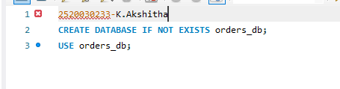
OUTPUT:
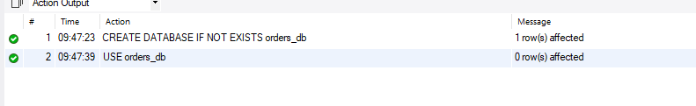
Query 2:CREATE TABLE
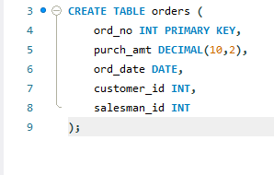
OUTPUT:
Query 3: ALTER TABLE ADD COLUMN
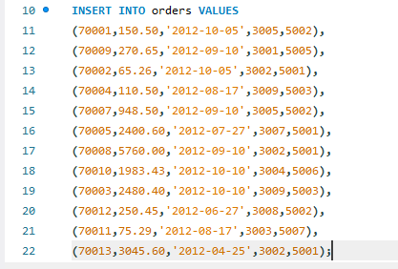
OUTPUT:

Query 4: ALTER TABLE MODIFY COLUMN
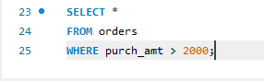
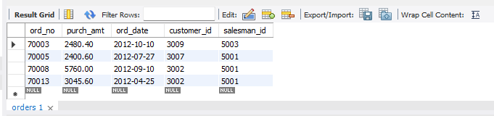
OUTPUT:

Query 5: ORDER BY

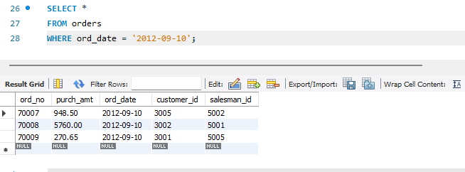
OUTPUT:

Query 6: SUM()
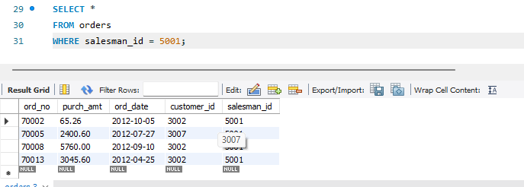
OUTPUT:
Query 7: AVG()

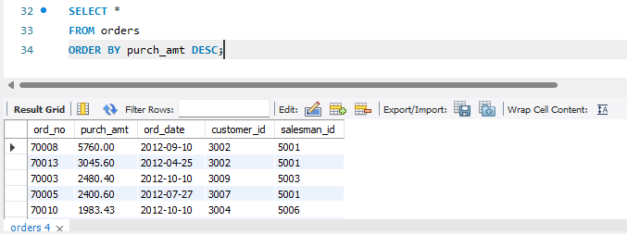
OUTPUT:
Query 8: MAX()
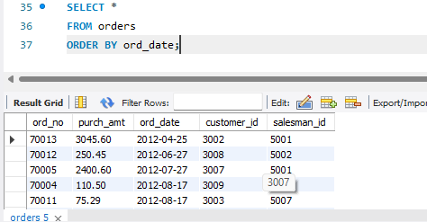
OUTPUT:
Query 9: MIN()
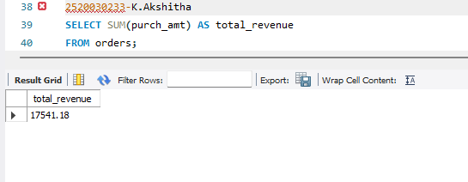
OUTPUT:
Query 10: COUNT()
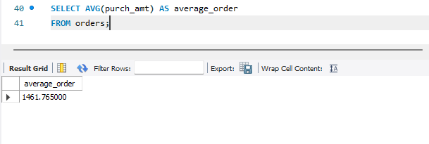
OUTPUT:
Query 11: GROUP BY

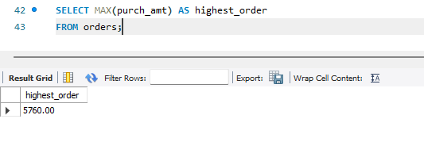
OUTPUT:
Query 12:GROUP BY
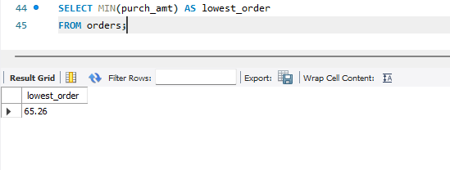
OUTPUT:
Query 13: GROUP BY + MAX()
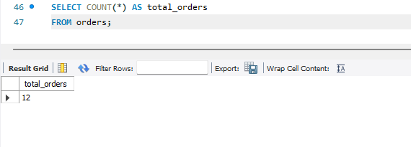
OUTPUT:

Query 14: GROUP BY + HAVING

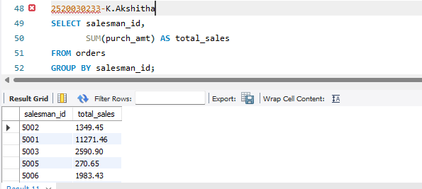
OUTPUT:

Query 15: GROUP BY + HAVING

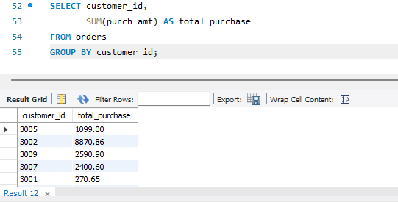
OUTPUT:
Query 16: GROUP BY + HAVING
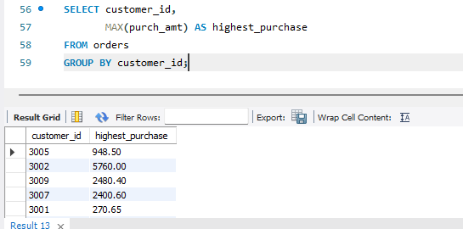
OUTPUT:
Query 17: GROUP BY + HAVING + ORDER BY

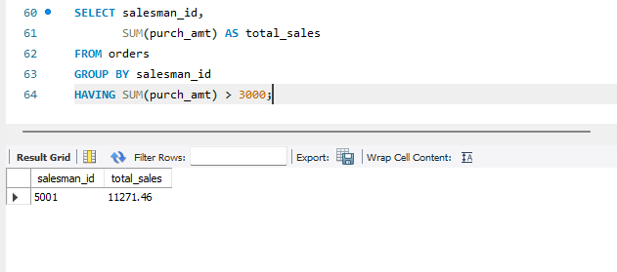
OUTPUT:
Query 18: BETWEEN + HAVING

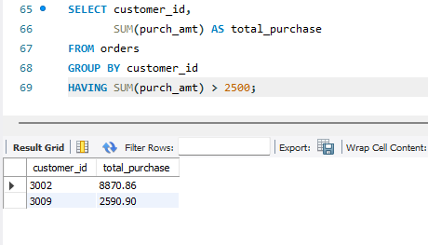
OUTPUT:
Query 19: COUNT + HAVING
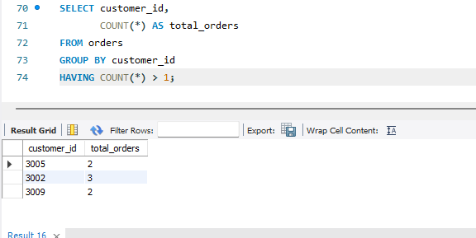
Output:
Query 20: MAX + GROUP BY + HAVING
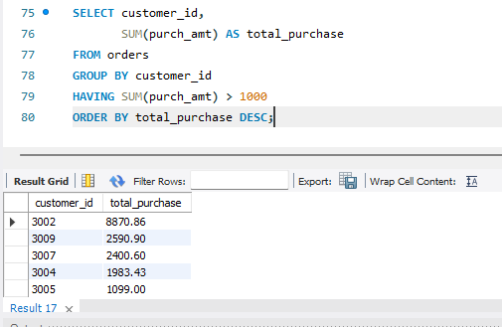
OUTPUT:
Query 21:
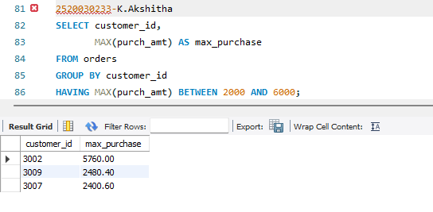
Output:
Query 22:
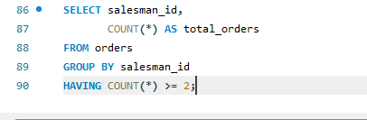
Output:
Query 23:
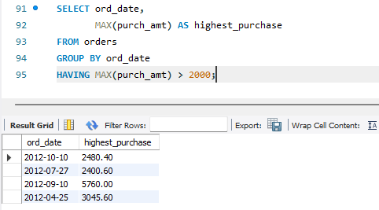
OUTPUT:

